Drug and Medication Administration Policy and Procedures
Name of Home Child Care Agency: Little Lambs Home Daycare Inc.
Date Policy and Procedures Established: January 2020
Date Policy and Procedures Updated: May 7th, annually/as needed

Purpose
The purpose of this policy and the procedures outlined within is to provide clear direction for Home child care Providers, staff, students and volunteers to follow for administering drugs or medication to children at the child care premises and for appropriate record-keeping.
Where the term drugs and/or medications is used in this policy, the term refers to any product with a drug identification number (DIN), with the exception of sunscreen, lotion, lip balm, bug spray, hand sanitizer and diaper cream that is not used for acute, symptomatic treatment. For the purpose of this policy, drugs and medications fall into the following two categories, unless otherwise specified:
- Prescription, intended for acute, symptomatic treatment; and
- Over-the-counter, intended for acute, symptomatic treatment.

The policy and procedures support children’s health, safety and well-being by setting out measures to:
- ensure children receive only those drugs or medications deemed necessary and appropriate by their parents;
- reduce the potential for errors;
- ensure medications do not spoil due to improper storage;
- prevent accidental ingestion;
- administer emergency allergy and asthma drugs or medications quickly when needed; and
- safely administer drugs and medications according to established routines.
This policy is intended to fulfill the obligations set out under Ontario Regulation 137/15 for the administration of drugs and medication in a child care centre.
Note: definitions for terms used throughout this policy are provided in a Glossary at the end of the document.

Policy

Parental Authorization to Administer Medication:
- Whenever possible, parents will be encouraged to administer drugs or medications to their children at home if this can be done without affecting the child’s treatment schedule.
- Prescription and over-the-counter medications for acute, symptomatic treatment will only be administered to a child where a parent of the child has given written authorization to do so by completing the child care centre’s Authorization for Medication Administration (see figure-1).
- The authorization must include a schedule that sets out the times the drug or medication is to be given and the amounts to be administered.
- Where a drug or medication is to be administered to a child on an “as needed” basis (i.e. there is no specific schedule or time of the day for administration) the medication administration form must clearly state all potential signs, symptoms and dosages required. Examples may include:
  - ‘when the child has a fever of 39.5 degrees Celsius’;
  - ‘when the child has a persistent cough and/or difficulty breathing’; and
  - ‘when red hives appear on the skin’, etc.
- Prescription/over-the-counter skin products (with a DIN) that need to be administered for acute or symptomatic treatment will only be administered to a child where a parent of the child has given written authorization to do so by completing the child care centre’s Authorization for Medication Administration.
- Authorization for Medical Administration Forms will be reviewed with parents any time the child’s condition changes, dosage/frequency is adjusted or the parent/guardian or child care provider feel it necessary. At least annually medication forms will be reviewed in combination with individual plans to ensure the dosage continues to be accurate (e.g. based on the child’s age or weight).
- A long as sunscreen, lotion, lip balm, bug spray, hand sanitizer and diaper cream are non-prescription and/or are not for acute (symptomatic) treatment, and due to their longer-term daily usage, these products:
- must have a blanket authorization from a parent on the enrolment form;
- can be administered without an Authorization for Medication Administration form; and
- do not require record-keeping

Figure-1 Authorization for Drug/Medication Administration form (PDF download available at www.littlelambshdc.com/providers)
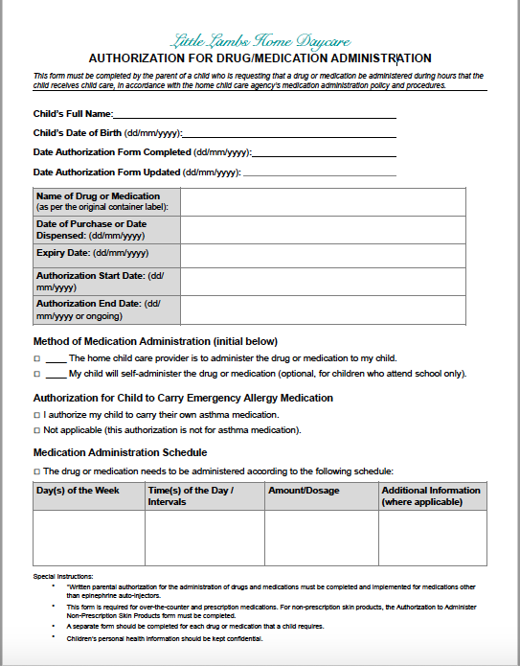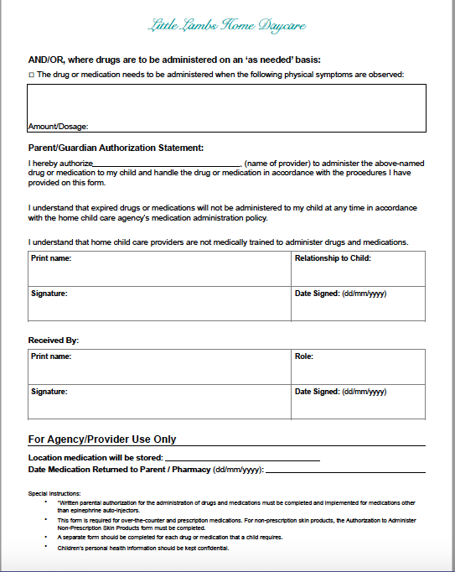

Drug and Medication Requirements
All drugs and medications to be administered to children must meet the following requirements:
- All drugs and medications must be stored in their original containers as supplied by a pharmacist, or their original packages. Medications that have been removed from their original package or transferred into a different container will not be accepted or administered to children.
- All drug or medication containers must be clearly labelled with:
- The child’s full name;
- The name of the drug or medication;
- The dosage of the drug or medication;
- Instructions for storage;
- Instructions for administration;
- The date of purchase of the medication for prescription medications; and
- The expiry date of the medication, if applicable.
- The information provided on the written parental authorization must match with all the requirements listed above.
- Where information is missing on a drug or medication label and/or the written parental authorization does not match the label on the labelled container, the child care provider will not accept or administer the medication until the label and/or written parental authorization accurately contains all the required information.
- Over-the-counter epinephrine purchased for a specific child can be administered to a child with an individualized plan and emergency procedures for an anaphylactic allergy as long as it is clearly labeled with the child’s name, the name of the drug or medication, the dosage, the date of expiration and the instructions for storage and administration.
Drugs or medications purchased by staff, students or volunteers for their own use will be kept inaccessible (e.g. stored in lockbox, locked cupboard) to children and will not be administered to children at any time.

Drug and Medication Handling and Storage:
- All drugs or medications will be kept inaccessible to children at all times in a locked container or area (e.g. in a refrigerator, cabinet, cupboard or drawer). There are exceptions for emergency medications as outlined below:
- Emergency medications will never be locked up and will be made easily accessible to the home child care provider and Little Lambs staff while being kept out of the reach of children, including during outdoor play periods and off-premises activities.
- Where a child has written permission to carry their emergency allergy or asthma medication, precautions will be taken to ensure that these medications are not accessible to other children (e.g., in cubbies or backpacks that are unattended).
- In case of an emergency the child care provider will ensure all staff, students and volunteers are made aware of the location of children’s emergency medications at all times.
- Emergency medications will be brought on all field trips, evacuations and off-premises activities.
- All drugs and medications for children will be stored in accordance with the instructions for storage on the label. Medication requiring refrigeration will be stored in the refrigerator in a locked container.
- Where drugs or medications are past their expiry date, they will be returned to the parent of the child, where possible, and this will be documented on the Authorization for Medication Administration Form.
- Any drugs or medications remaining after the treatment period will be returned to a parent of the child, where possible, and this will be documented on the Authorization for Medication Administration Form.

Drug and Medication Administration:
- Drugs or medications will be administered by the Home Child Care Provider according to the instructions on the label and only with written parental authorization.
- Volunteers, students, other persons at the home child care premises (providers spouse/partner, family members) are not permitted to administer drugs/medications.
- A drug or medication will only be administered from its original container as supplied by a pharmacist or its original package, and where the container is clearly labelled as outlined under the Drug and Medication Requirements section of this policy.
- A drug or medication will only be administered using the appropriate dispenser (e.g. syringe, measuring spoon/cup, etc.).
- To support the prompt administration of emergency medication:
- Emergency medications may be administered to a child by any person trained on the child’s individualized plan at the child care premises; and
- Children will be allowed to carry their own asthma or emergency medication in accordance with this policy, the drug and medication administration procedures, and the child’s individualized plan, where applicable.
- Drugs or medications that are expired (including epinephrine) will not be administered at any time.

Record-Keeping:
- Records of medication administration will be completed using the Records of Medication Administration (see figure-2) every time drugs or medications are administered. Completed records will be kept in the child care providers binder filed under the child’s name for easy access.
- Where a child’s medication administration form includes a schedule setting out specific times to administer the medication and the child is absent on a day medication would have been administered, the child’s absence will be documented on the medication administration record to account for all days during the treatment period (excluding weekends, holidays and planned closures).
- If a dose is missed or given late, reasons will be documented on the record of medication administration and a parent will be notified as soon as possible as it may impact the treatment schedule or the child’s health.
- Where a drug or medication is administered ‘as needed’ to treat specific symptoms outlined in a child’s medication administration form or individualized plan and emergency procedures for an anaphylactic allergy (e.g. asthma, fever, allergic reaction), the administration and the reason for administering will be documented in the child’s HiMama daily record and in the child’s symptoms of illness record. A parent of the child will be notified.

Figure-2 Record of Drug/Medication Administration ((PDF download available at www.littlelambshdc.com/providers)

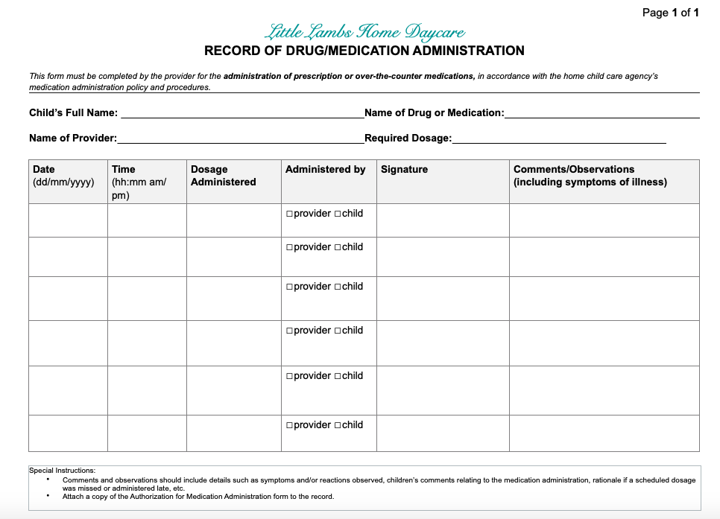

Confidentiality
- Information about a child’s medical needs will be treated confidentially and every effort will be made to protect the privacy of the child, except when information must be disclosed for the purpose of implementing the procedures in this policy and for legal reasons (e.g. to the Ministry of Education, College of Early Childhood Educators, law enforcement authorities or a Children’s Aid Society).

Glossary
Drug Identification Number (DIN): An eight-digit number assigned by Health Canada to a drug product prior to being marketed in Canada. It uniquely identifies all drug products sold in a dosage form in Canada and is located on the label of prescription and over-the-counter drug products that have been evaluated and authorized for sale in Canada.

Drug or Medication: Any product with a drug identification number (DIN), with the exception of sunscreen, lotion, lip balm, bug spray, hand sanitizer and diaper cream that is not used for acute, symptomatic treatment. Drugs and medications fall into the following two categories, unless otherwise specified in this policy:
  - Prescription, intended for acute, symptomatic treatment; and
  - Over-the-counter, intended for acute, symptomatic treatment.

Emergency Medication: Prescription drugs or medications that are used in case of an urgent medical reaction that requires immediate treatment. Emergency medications include medications used to treat asthma (e.g. puffers) and anaphylactic allergies (e.g. epinephrine).

Licensee: The individual or corporation named on the licence issued by the Ministry of Education responsible for the operation and management of the child care centre.

Child Care Provider: the individual contracted by the licensee to provide home child care services

Parent: A person having lawful custody of a child or a person who has demonstrated a settled intention to treat a child as a child of his or her family (all references to parent include legal guardians, but will be referred to as “parent” in the policy).

Person who is in Charge of All Drugs and Medications (a.k.a. the ‘person in charge’): The individual at the child care premises who is responsible for administering medication to children.

Staff (Employee): Individual employed by the licensee (e.g. RECE Home Visitor).

