Anaphylactic Policy and Procedures
Name of Home Child Care Agency: Little Lambs Home Daycare Inc.
Date Policy and Procedures Established: January 2020
Date Policy and Procedures Updated: May 7th, 2020 (annually thereafter or as needed)

Purpose
Anaphylaxis is a serious allergic reaction that can be life-threatening. It requires avoidance strategies and immediate response in the event of an emergency. These policies and procedures are intended to help meet the needs and save the lives of children with severe allergies and provide relevant and important information on anaphylaxis to parents, staff, providers, students, volunteers and other persons at a home child care premises.
This policy is intended to fulfill the obligations set out under Ontario Regulation 137/15 for an anaphylactic policy for home child care agencies. The requirements set out in this policy align with Sabrina’s Law, 2005.
Note: definitions for terms used throughout this policy are provided in a Glossary at the end of the document.

Policy
Individualized Plans and Emergency Procedures for Children with Life-Threatening/Anaphylactic Allergies
- Before a child is placed at a home child care premises, the licensee/designate and/or home child care provider will meet with the parent of a child enrolled through the home child care agency to obtain information about any medical conditions, including whether the child is at risk of having or has anaphylaxis.
- Before a child begins to receive care at a home child care premises or upon discovering that a child has an anaphylactic allergy, an individualized anaphylactic plan will be developed for each child with anaphylaxis in consultation and collaboration with the child’s parent, and any regulated health professional who is involved in the child’s care that the parent believes should be included in the consultation (see Figure-1).
- All individualized plans and emergency procedures will include a description of symptoms of an anaphylactic reaction that are specific to the child and the procedures to be followed in the event of an allergic reaction or other medical emergency based on the severity of the child’s symptoms.
- The individualized plan and emergency procedures for each child will include information for those who are in direct contact with the child on a regular basis about the type of allergy, monitoring and avoidance strategies and appropriate treatment.
- All individualized plans and emergency procedures will be made readily accessible at all times to all home child care providers and to all home child care agency home visitors, students and volunteers and will be kept in the child’s binder, on Hi Mama, and in the home child care providers travel bag.
- All individualized plans and emergency procedures will be reviewed with a parent of the child annually or sooner if required to ensure the information is current and up to date.
- Every child’s epinephrine auto-injector must be carried everywhere the child goes.

Figure 1-individualized plan for a child with anaphylactic needs (download available @ www.littlelambshdc.com/providers or from the agency head office)
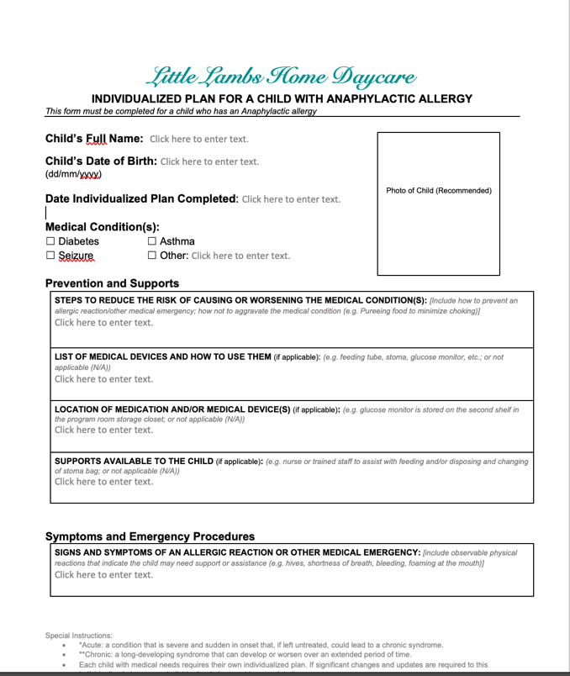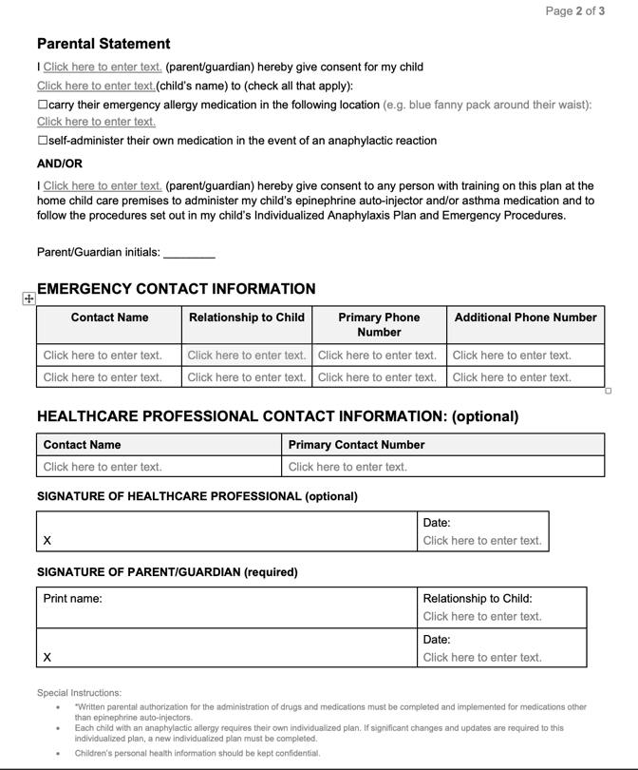

Strategies to Reduce the Risk of Exposure to Anaphylactic Allergens
The following strategies to reduce the risk of exposure to anaphylactic causative agents must be followed at all times by home visitors of the home child care agency, as well as providers, other persons regularly present or ordinarily resident, students and volunteers at each home child care premises.
- Do not serve foods where its ingredients are not known.
- Do not serve items with ‘may contain’ warnings on the label in a premises with a child who has an individualized plan and emergency procedures specifying those allergens.
- Ensure that parents label food brought to the premises with the child’s full name and the date the food arrived at the premises, and that parents advise of all ingredients.
- Where food is provided from home for children, ensure that appropriate supervision of children is maintained so that food is not shared or exchanged.
- Encourage parents who serve foods containing allergens at home to ensure their child has been rid of the allergens prior to attending the home child care premises (e.g. by thoroughly washing hands, brushing teeth, etc.)
- Do not use craft/sensory materials and toys that have known allergens on the labels.
- Share information about anaphylaxis, strategies to reduce the risk of exposure to known allergens and treatment with all families of children receiving care at the premises.
- Make sure each child’s individual plan and emergency procedures are kept-up-to-date and that all home child care agency home visitors, providers, other persons regularly present and ordinarily resident, students, and volunteers at the home child care premises are trained on the plans.
- Create allergy lists for each home child care premises and ensure that they are up to date in each premises and implemented.
- Update providers, other persons regularly present and ordinarily resident, home visitors, students, and volunteers when changes to a child’s allergies, signs and symptoms, and treatment occur and review all updates to individualized plans and emergency procedures.
- Update families when changes to allergies occur for a child receiving care at a premises while maintaining the confidentiality of children.
- The strategies in this policy will be updated or revised and implemented depending on the Communication Plan
The following is our communication plan for sharing information on life-threatening and anaphylactic allergies with home child care providers, home child care agency home visitors, students, volunteers, parents and families.
- Parents will be encouraged not to bring foods to home child care premises that contain ingredients to which children may be allergic
- Parents and families will be informed about anaphylactic allergies and all known allergens at the home premises in which their child is placed through written and verbal communication. All known allergens will be listed on the Providers communication board. It is recommended families review communication boards whenever able.
- A list of all children’s allergies including food and other causative agents will be posted in all cooking areas at each home child care premises, and will be made available in any other area where children may be present.
- Each child with an anaphylactic allergy who is enrolled at a home child care premises through the home child care agency will have an individualized plan and emergency procedures that detail signs and symptoms specific to the child describing how to identify that they are having an allergic reaction and what to do if they experience a reaction.
- Each child’s individualized plan and emergency procedures will be made available and accessible wherever the child may be present while receiving child care. Little Lambs utilizes a child care app (electronic cloud software) called HiMama. All children have an individual profile uploaded to the app. The software enables any device with a WIFI connection to access important information including “individual plans.” (each child care provider has their own classroom login, parents can login and review their child’s information as well). If WIFI connection is unavailable the provider will have a physical copy in the child’s binder and in their travel bag.
- In cases where a child has food allergies and the meals and snacks provided by the provider cannot meet the child’s needs, the parent may be asked to supply snacks/meals for their child. All written instructions for diet provided by a parent will be implemented.
- The home child care agency will communicate with the Ministry of Education by reporting serious occurrences where a life-threatening situation occurs in accordance with the established serious occurrence policy and procedures.
- This communication plan will be continually reviewed to ensure it is meeting the needs of the home child care agency and that it is effectively achieving its intended result.
Drug and Medication Requirements
- Where drugs or medications will need to be administered to a child in response to an anaphylactic reaction, the drug and medication administration policy will be followed including the completion of a parental authorization form to administer drugs or medications.
- Emergency allergy medication (e.g. oral allergy medications, puffers and epinephrine auto-injectors) will be allowed to be carried by children with parental authorization so that they can be administered quickly when needed.

Training
- Providers and/or home visitors will ensure that they receive training from a parent of a child with anaphylaxis on the procedures to follow in the event of a child having an anaphylactic reaction, including how to recognize the signs and symptoms of anaphylaxis and administer emergency allergy medication.
- Once the provider and home visitor have been trained, they will ensure training is provided to all other persons regularly present and ordinarily resident, students and volunteers.
- Training will be repeated annually and any time there are changes made to any child’s individualized plan and emergency procedures.
- Every attempt will be made to provide a “trainer Epi-Pen” for the Home Visitor, home child care provider, all other persons regularly present and ordinarily resident, students and volunteers. A trainer Epi-Pen does not actually contain medication but provides the opportunity to test the strength required to administer the medication.
- A written record of training on procedures to be followed for each child who has an anaphylactic allergy in a home child care premises will be kept for home child care agency home visitors, providers, other persons regularly present and ordinarily resident, students and volunteers at the premises, including the names of individuals who have not yet been trained. This will ensure that training is tracked and follow-up is completed where an individual has missed or not received training. See Figure-2.
Figure 2-Training and Consent (download available @ www.littlelambshdc.com/providers or from the agency head office)

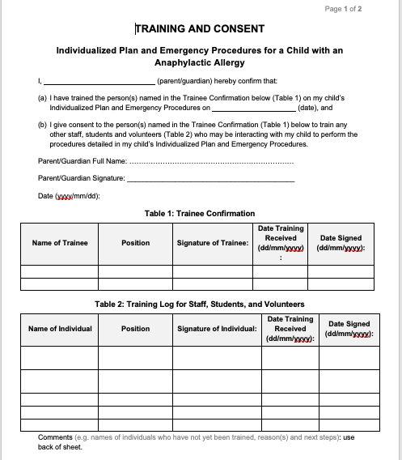

Confidentiality
- Information about a child’s allergies and medical needs will be treated confidentially and every effort will be made to protect the privacy of the child, except when information must be disclosed for the purpose of implementing the procedures in this policy and for legal reasons (e.g. to the Ministry of Education, College of Early Childhood Educators, law enforcement authorities or a Children’s Aid Society).

Procedures to be followed in the circumstances described below:
Circumstance | Roles and Responsibilities
- A child exhibits an anaphylactic reaction to an allergen | - The person who becomes aware of the child’s anaphylactic reaction must immediately:  - implement the child’s individualized plan and emergency procedures;  - contact emergency services and a parent/guardian of the child, or have another person do so where possible;  - ensure that where an epinephrine auto-injector has been used, it is properly discarded (i.e. given to emergency services, or in accordance with the drug and medication administration policy).  - Once the child’s condition has stabilized or the child has been taken to hospital, the provider must:  - follow the home child care agency’s serious occurrence reporting policies and procedures;  - document the incident in the daily written record; and  - document the child’s symptoms of ill health in the child’s records.
- A child is authorized to carry his/her own emergency allergy medication. | - The provider must:  - ensure that written parental authorization is obtained to allow the child to carry their own emergency allergy medication;  - ensure that the medication remains on the child (e.g., fanny pack, holster) and is not kept or left unattended (e.g. in the child’s backpack);  - ensure that appropriate supervision is maintained of the child while carrying the medication and of children in their close proximity so that other children do not have access to the medication; and  - Where there are safety concerns relating to the child carrying his/her own medication (e.g. exposure to other children), notify the home child care agency or home visitor and the child’s parent of these concerns, and discuss and implement mitigating strategies. Document the concerns and resulting actions in the daily written record.

Glossary
Causative Agent (allergen/trigger): a substance that causes an allergic reaction. Common allergens include, but are not limited to:
- eggs
- milk
- mustard
- peanuts
- seafood including fish, shellfish, and crustaceans
- sesame
- soy
- sulphites which are food additives
- tree nuts
- wheat
- latex
- insect stings
Anaphylaxis: a severe systemic allergic reaction which can be fatal, resulting in circulatory collapse or shock. Symptoms can vary for different people, and can be different from one reaction to the next, including:
- Skin: hives, swelling, itching, warmth, redness, rash
- Breathing (respiratory): coughing, wheezing, shortness of breath, chest pain/tightness, throat tightness/swelling, hoarse voice, nasal congestion or hay fever-like symptoms (runny nose and watery eyes, sneezing), trouble swallowing
- Stomach (gastrointestinal): nausea, pain/cramps, vomiting, diarrhea
- Heart (cardiovascular): pale/blue colour, weak pulse, passing out, dizzy/lightheaded, shock
- Other: anxiety, feeling of “impending doom”, headache, uterine cramps, metallic taste in mouth
(Source: http://foodallergycanada.ca/about-allergies/anaphylaxis/)

Epinephrine: A drug used to treat allergic reactions, particularly anaphylaxis. This drug is often delivered through an auto-injector (e.g. EpiPen or Allerject).

Home Child Care Provider (“provider”): An individual who is in charge of the children receiving care at the home premises. The home child care agency screens, approves, and monitors providers with whom it has established contractual agreements to provide child care.

Licensee: The individual or corporation named on the licence issued by the Ministry of Education responsible for the operation and management of the home child care agency.

Ordinarily a Resident of the Premises (“ordinarily resident”): Individuals who may have access to children in care (including supervised access) because they use the premises as a primary residence for at least some period during the year (e.g., the provider’s spouse, adult children, adult dependents, etc.).

Parent: A person having lawful custody of a child or a person who has demonstrated a settled intention to treat a child as a child of his or her family (all references to parent include legal guardians, but will be referred to as “parent” in the policy).

Regularly at the Premises (“regularly present”): An individual who is present at the premises during hours in which care is provided often enough that children in care are able to recognize the individual. This would include persons who are present frequently during a short period of time (e.g., visiting family members) or repeatedly (e.g., the provider’s friend who visits the premises once a week, or a neighbour who visits the premises every other month to provide tutoring to the provider’s own child).

